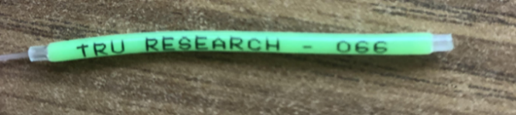
MARK-RECAPTURE DATA SHEET
Name:
Instructions: Please print sheet and record all information when fishing smallmouth bass in Cultus Lake. If you catch a bass with a pink tag, please release immediately. If you catch a bass with green tag or no tag, please kill. All non-tagged bass can be recorded and killed.
Fishing can start any time after June 19th. Please send data sheets to wendymargetts1@gmail.com
Thank you for your help with this important project!
Date | # Hours Spent Fishing | Tag # (see picture) | Length (mm) | Location | Released/Killed
(Ex.) June 20, 2021 | 1.5 | 066 | 240 mm | Docks on Main Beach | Killed
(Ex.) June 20, 2021 | 1.5 | No Tag | 240 mm | Docks on Main Beach | Killed

**REMEMBER PINK = RELEASE, GREEN = KILL

